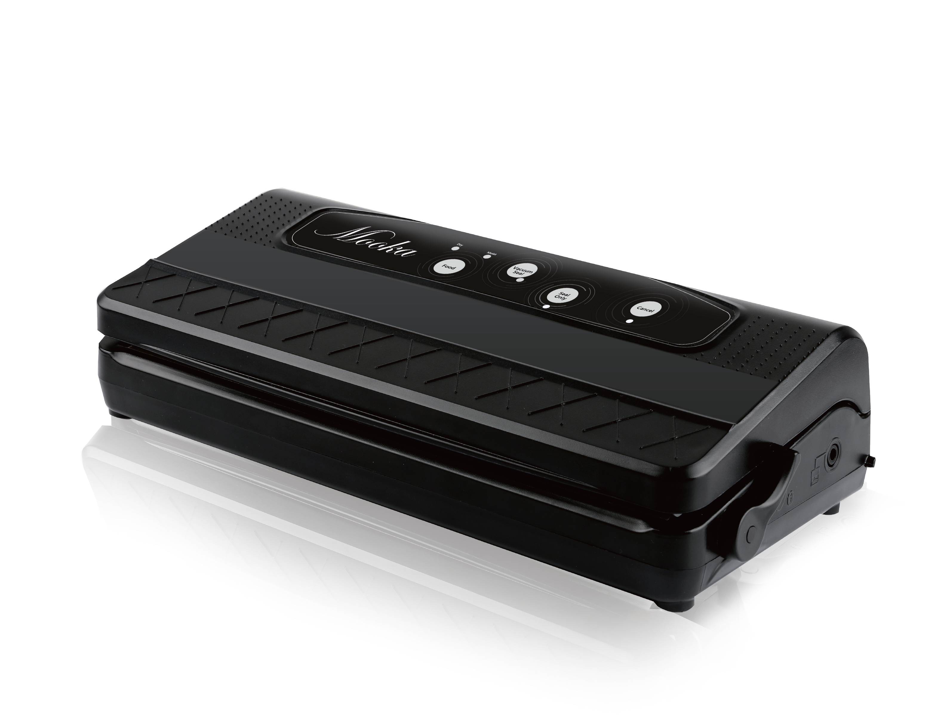

2

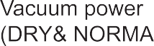

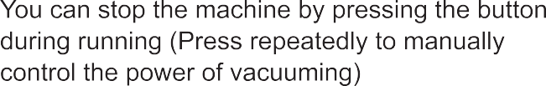
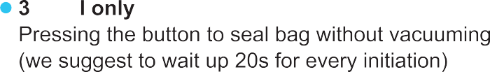
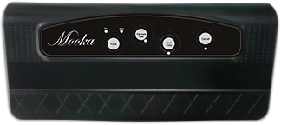

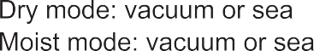

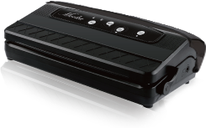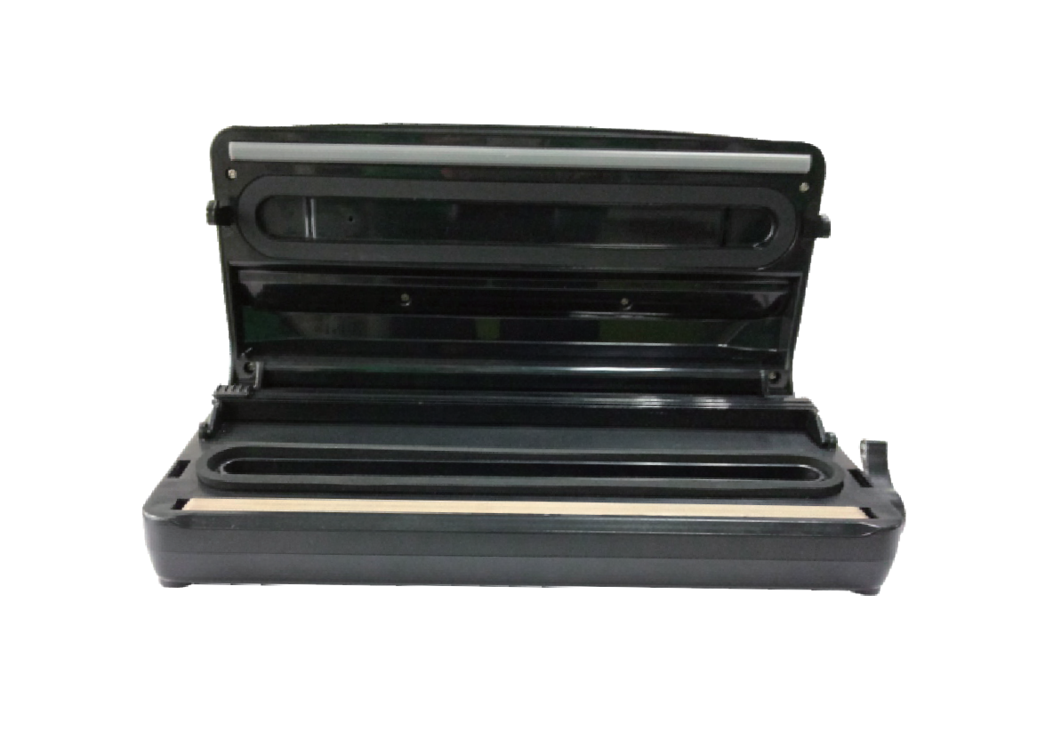

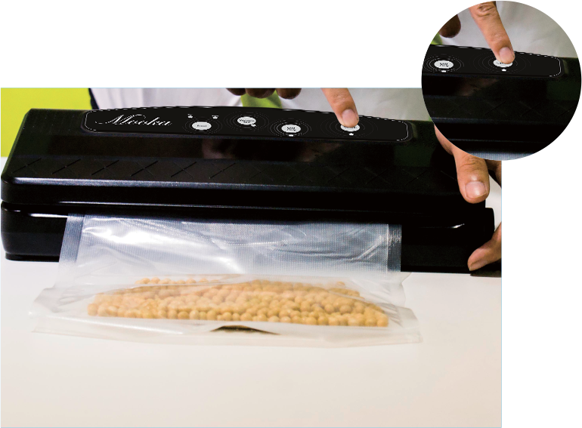
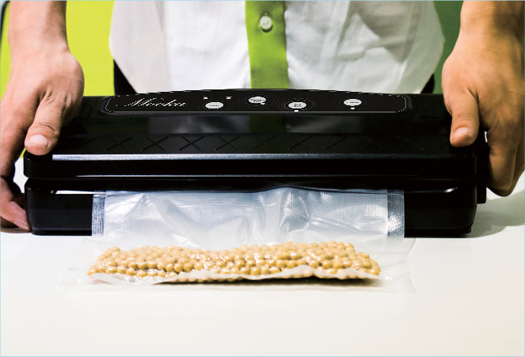
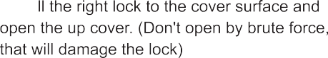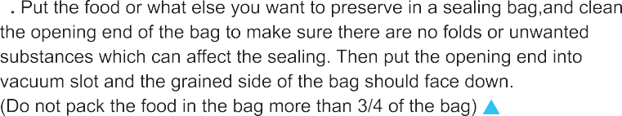

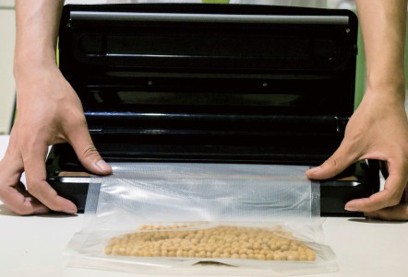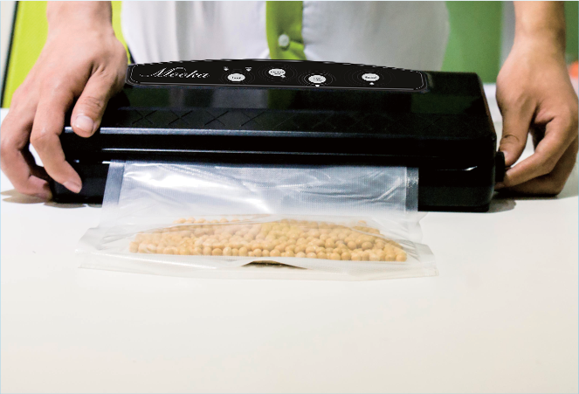

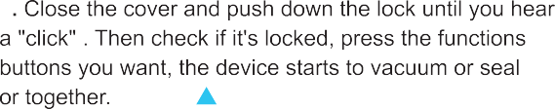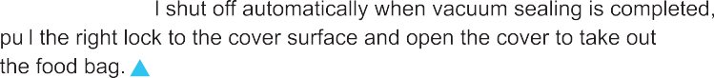

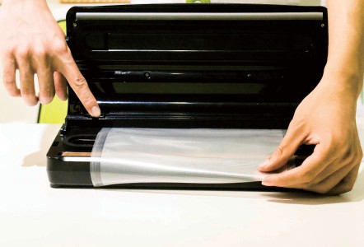
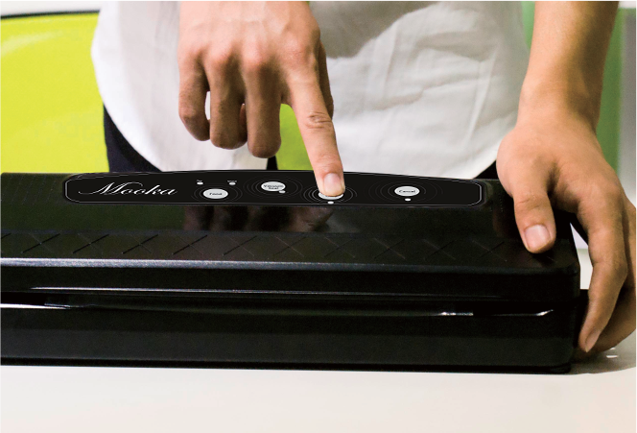
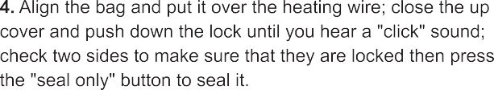
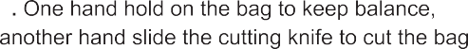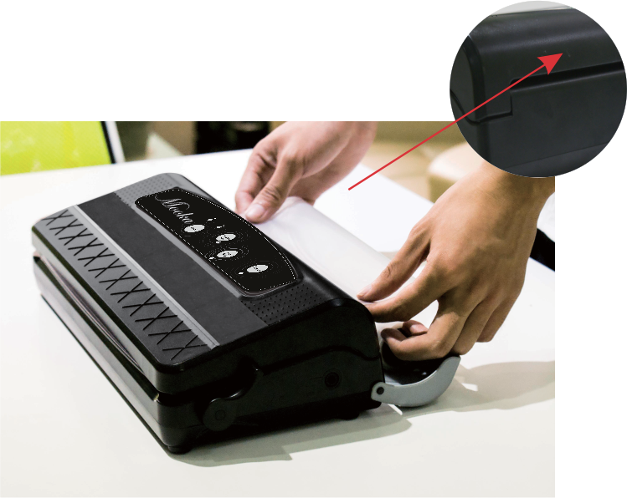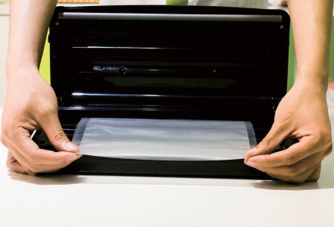

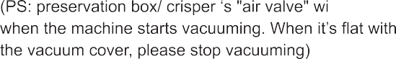

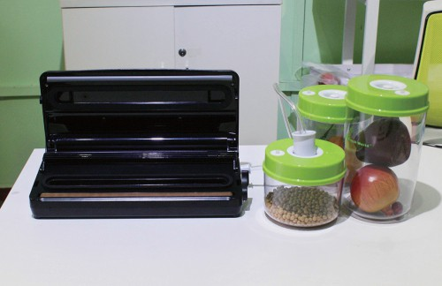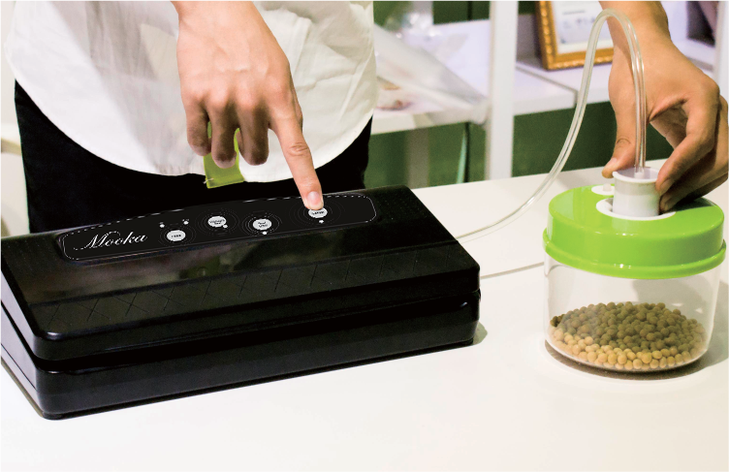
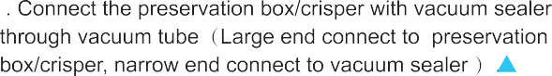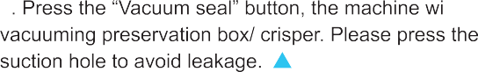

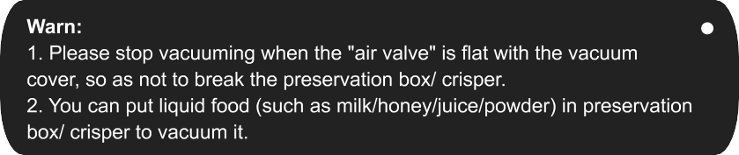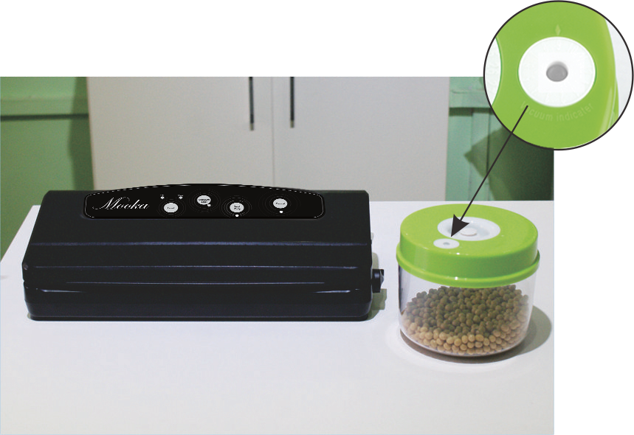

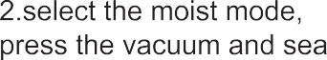

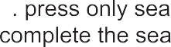

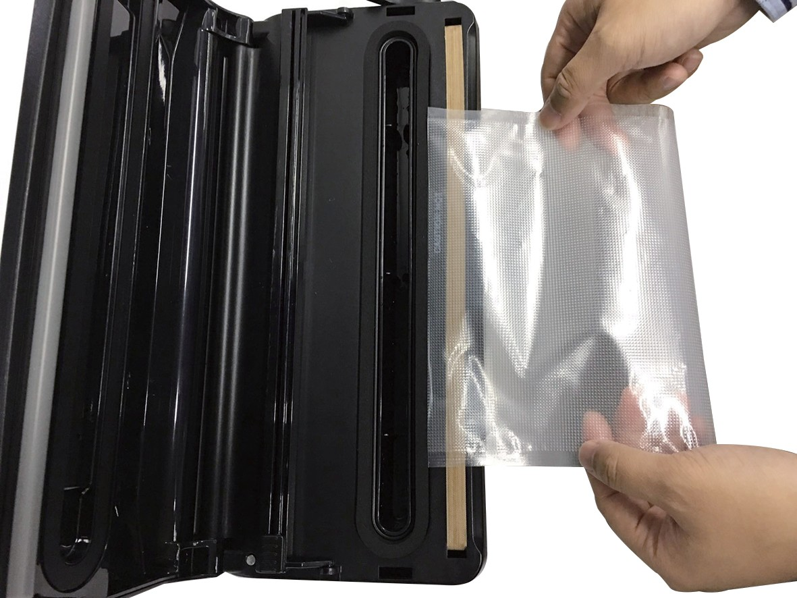
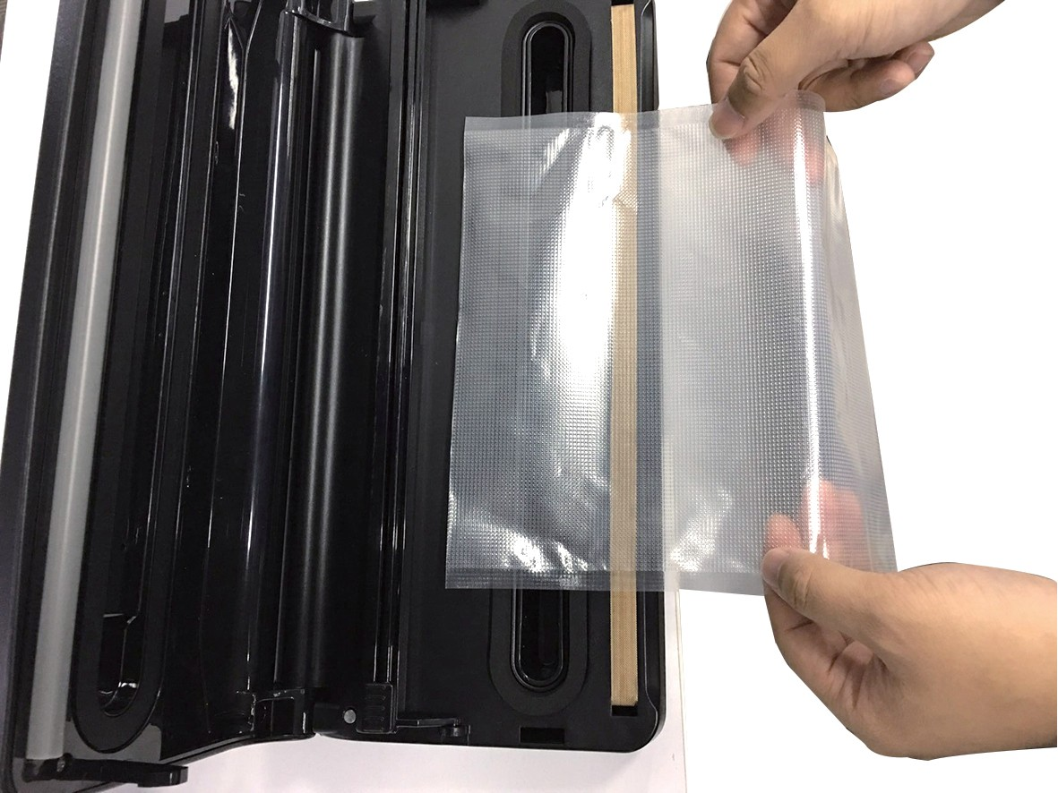
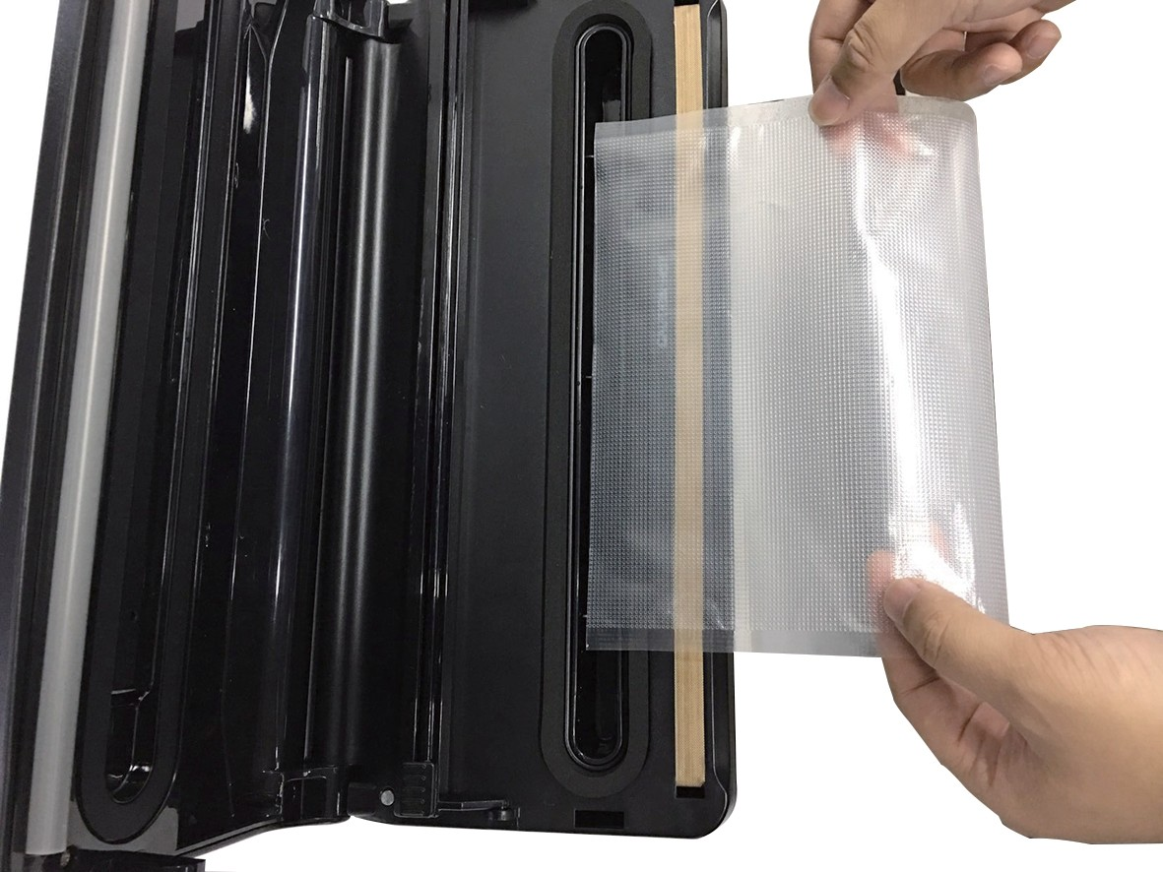

Product not as expected
Do not like the product Problem with user manual Missing accessories
Package damaged
Contact us for instructions
Contact us for instructions
Contact us to get them
Contact us for compensation
Dear customer,
Thank you for purchasing a Mooka product. Please keep this card for guarantee! Every Mooka product has a 1-year warranty.

Not Satisfied?

Quality problem?
No hassle fast full refund or Replacement
- Contact us by Amazon Message
- Contact us by email: support@mookapro.com

What you’ll get for contacting us at support@mookapro.com:
- A reply within 12 working hours.
- Professional technician support.

Contact us directly for any questions or more information. We’ll be more than happy to help solve any problem you have!

Lot2, Beijiao Industry Park, Beijiao Town, Shunde District, Foshan, Guangdong Province, P.R. China FOSHAN SHUNDE DEERMA ELECTRIC APPLIANCES CO., LTD

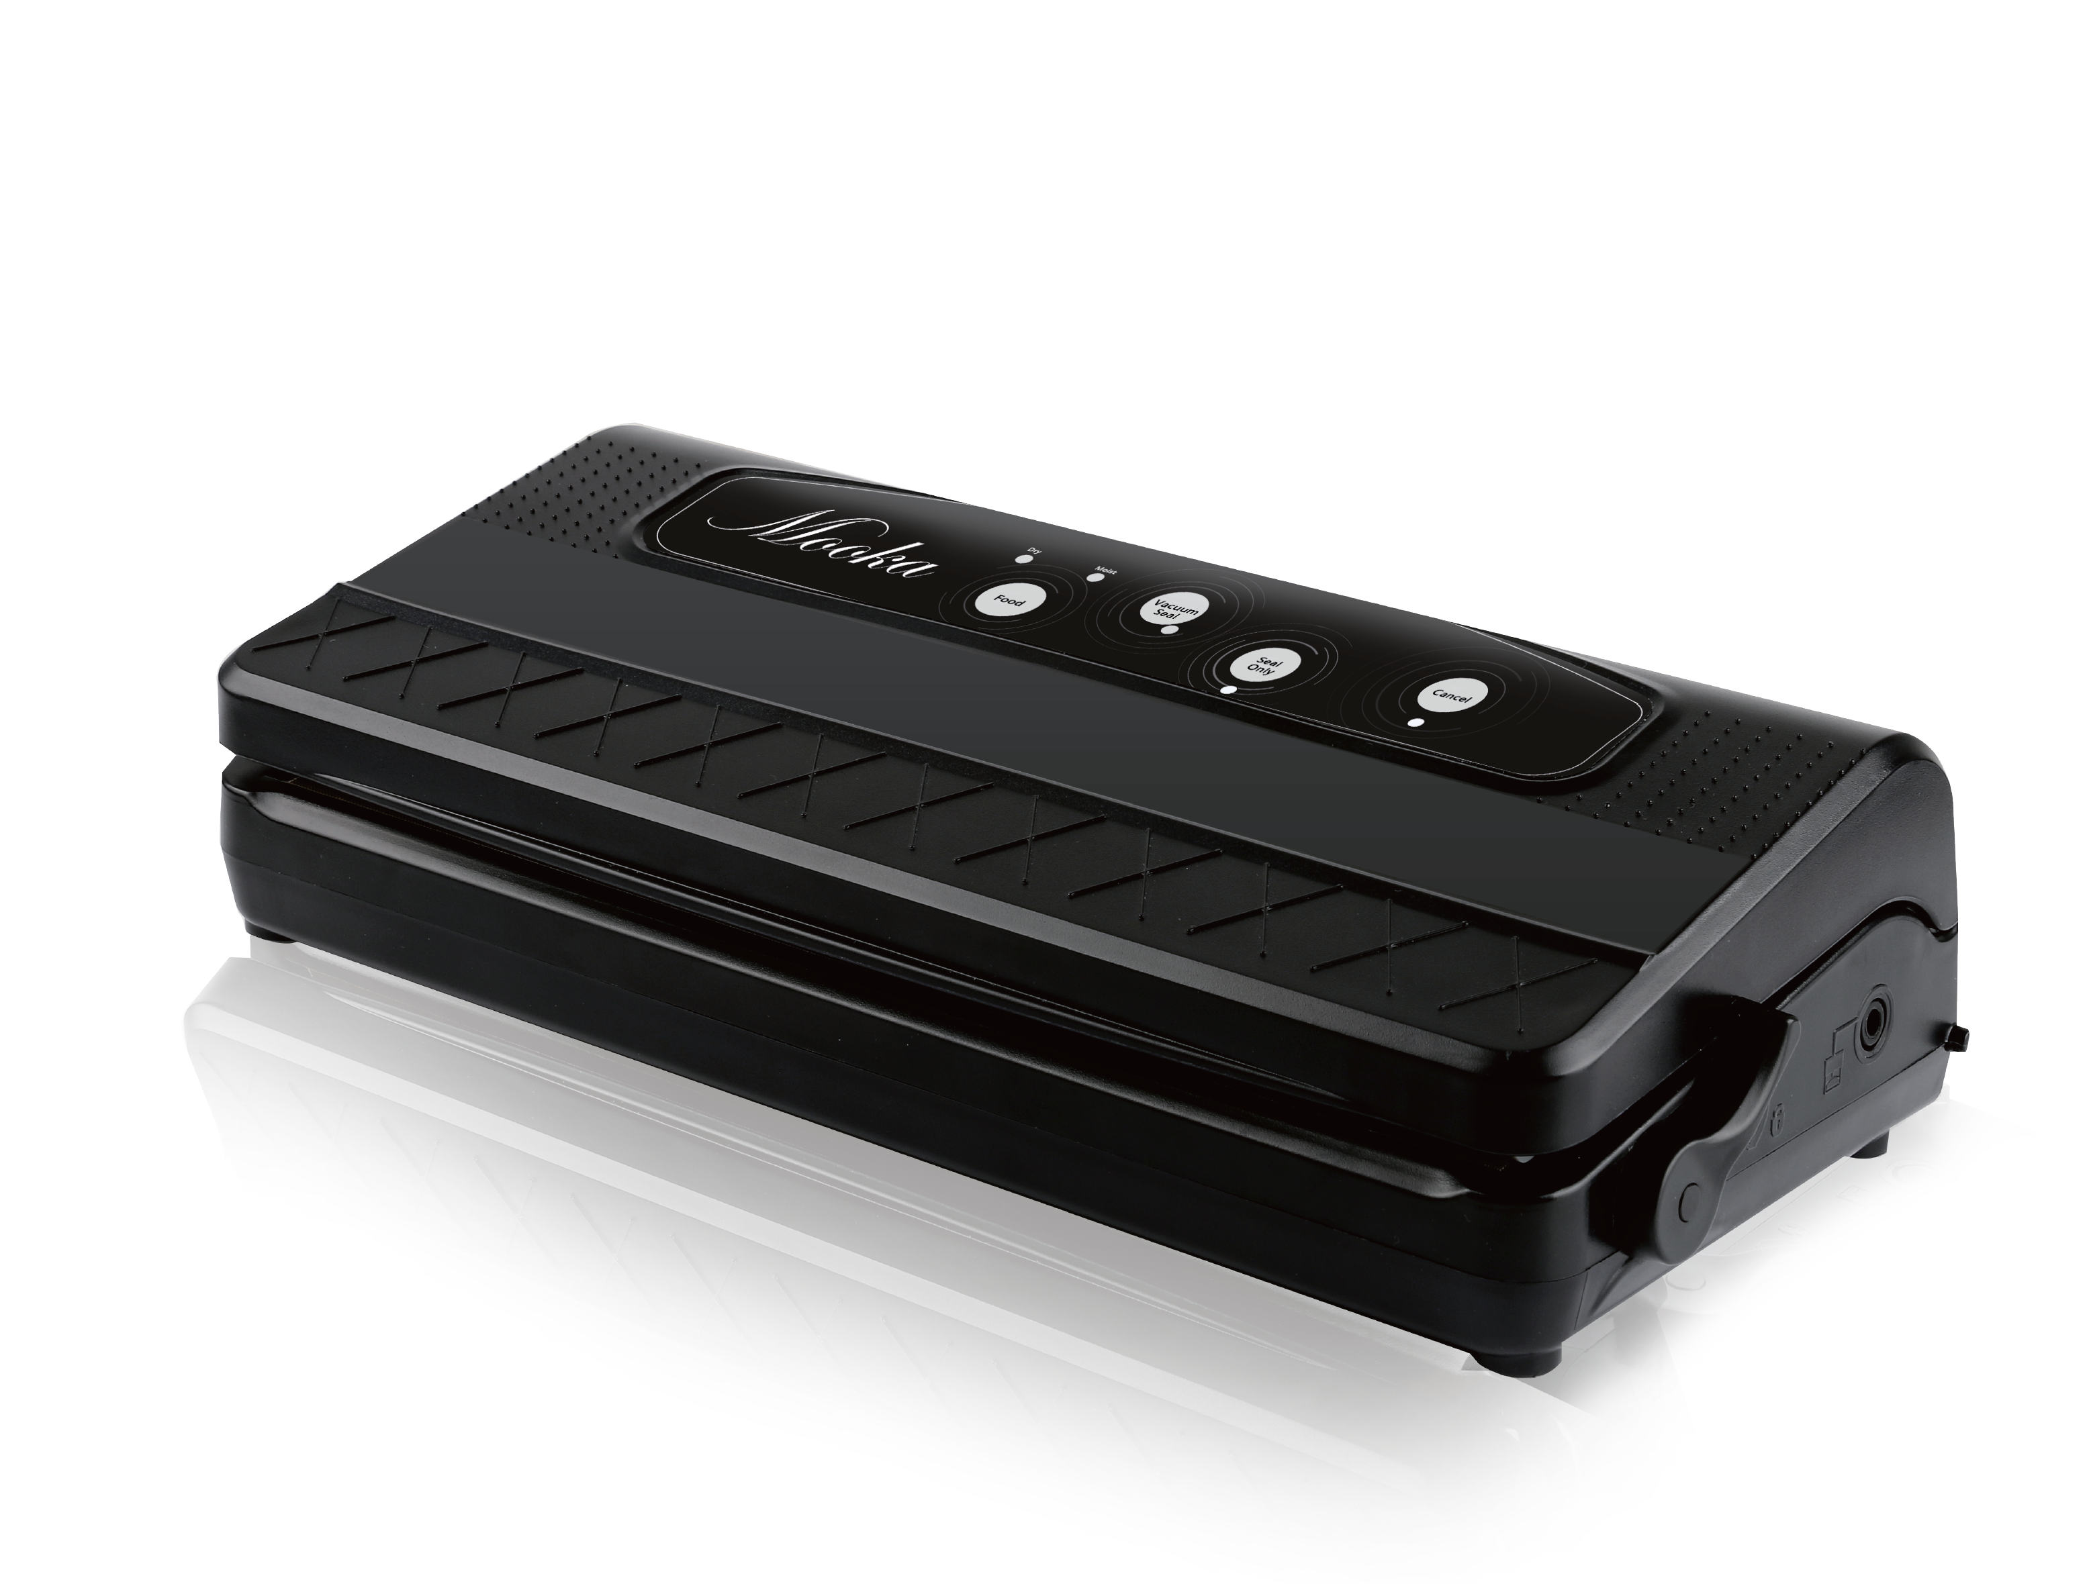

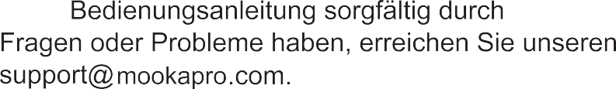

2 3 4

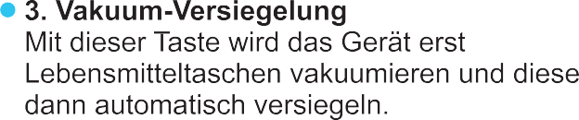
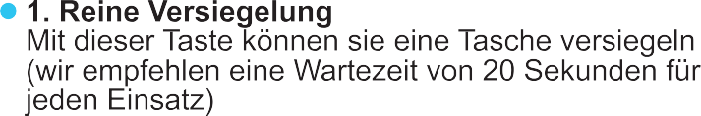
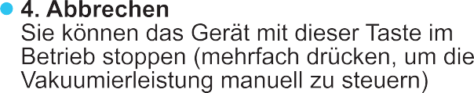
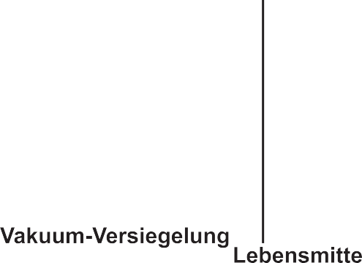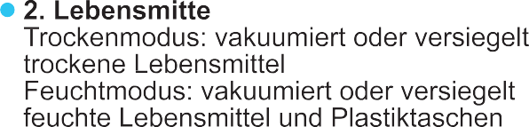

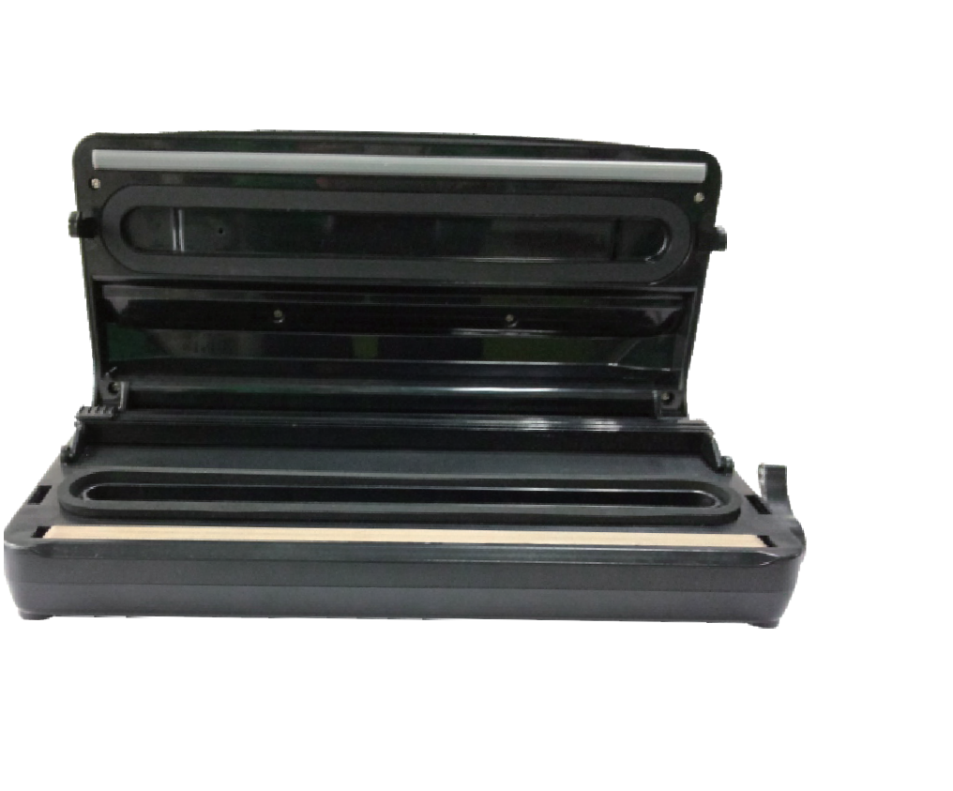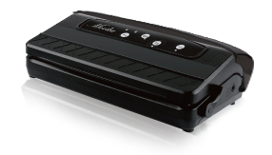

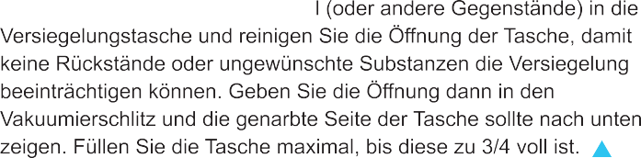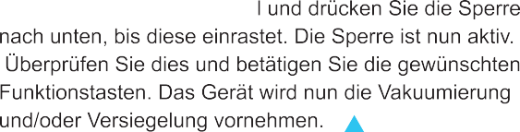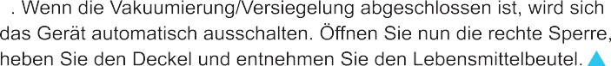

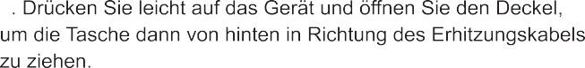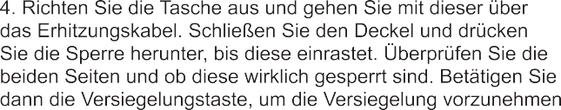

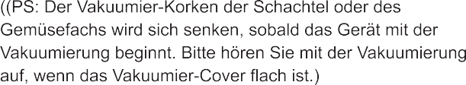
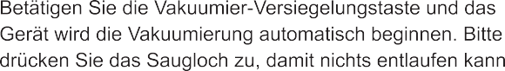

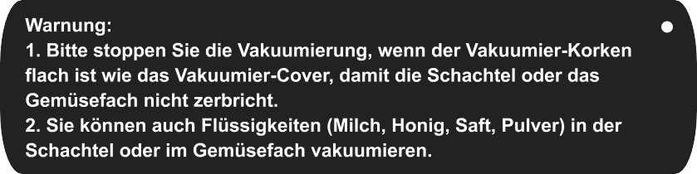

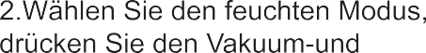
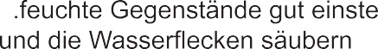

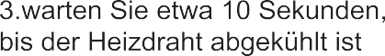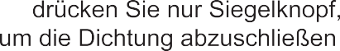

Product not as expected
Do not like the product Problem with user manual Missing accessories
Package damaged
Contact us for instructions
Contact us for instructions
Contact us to get them
Contact us for compensation
Dear customer,
Thank you for purchasing a Mooka product. Please keep this card for guarantee! Every Mooka product has a 1-year warranty.

Not Satisfied?

Quality problem?
No hassle fast full refund or Replacement
- Contact us by Amazon Message
- Contact us by email: support@mookapro.com

What you’ll get for contacting us at support@mookapro.com:
- A reply within 12 working hours.
- Professional technician support.

Contact us directly for any questions or more information. We’ll be more than happy to help solve any problem you have!

Lot2, Beijiao Industry Park, Beijiao Town, Shunde District, Foshan, Guangdong Province, P.R. China FOSHAN SHUNDE DEERMA ELECTRIC APPLIANCES CO., LTD

DECLARATION OF CONFORMITY
I hereby declare that the product
Name of product :Vacuum Sealer type or model: TVS-2150
Trade : Mooka

(Name of product, type or model, batch or serial number)
satisfies all the technical regulations applicable to the product within the scope of Council Directives.

ApplicableStandards
EN 55014-1:2006+A1:2009+A2:2011 EN 61000-3-2:2014
EN 61000-3-3:2013 EN 55014-2:2015
Standard.............................................
EN 60335-2-14: 2006+A1:2008+A11:2012 used in conjunction with
EN 60335-1:2012+A11:2014

� MANUFACTURER or AUTHORISED REPRESENTATIVE::
� Address

GUANGZHOU FRESH WORLD ELECTRICAL APPLIANCE CO., LTD

TuanJie Ave, HuaDu District, GuangZhou, 510800, China

The product have been tested by us with listed standards and found in compliance with the
council LVD(Low Voltage Directive)2014/35/EU. It is possible to use CE marking to demonstrate the compliance with this Low Voltage Directive.
This declaration is issued under the sole responsibility of the manufacturer and, if applicable, his authorised representative.

2017-10-23

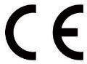
Point of contact: 86-020-36700521

Signature: 黄小红

