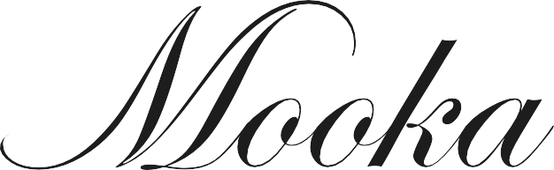

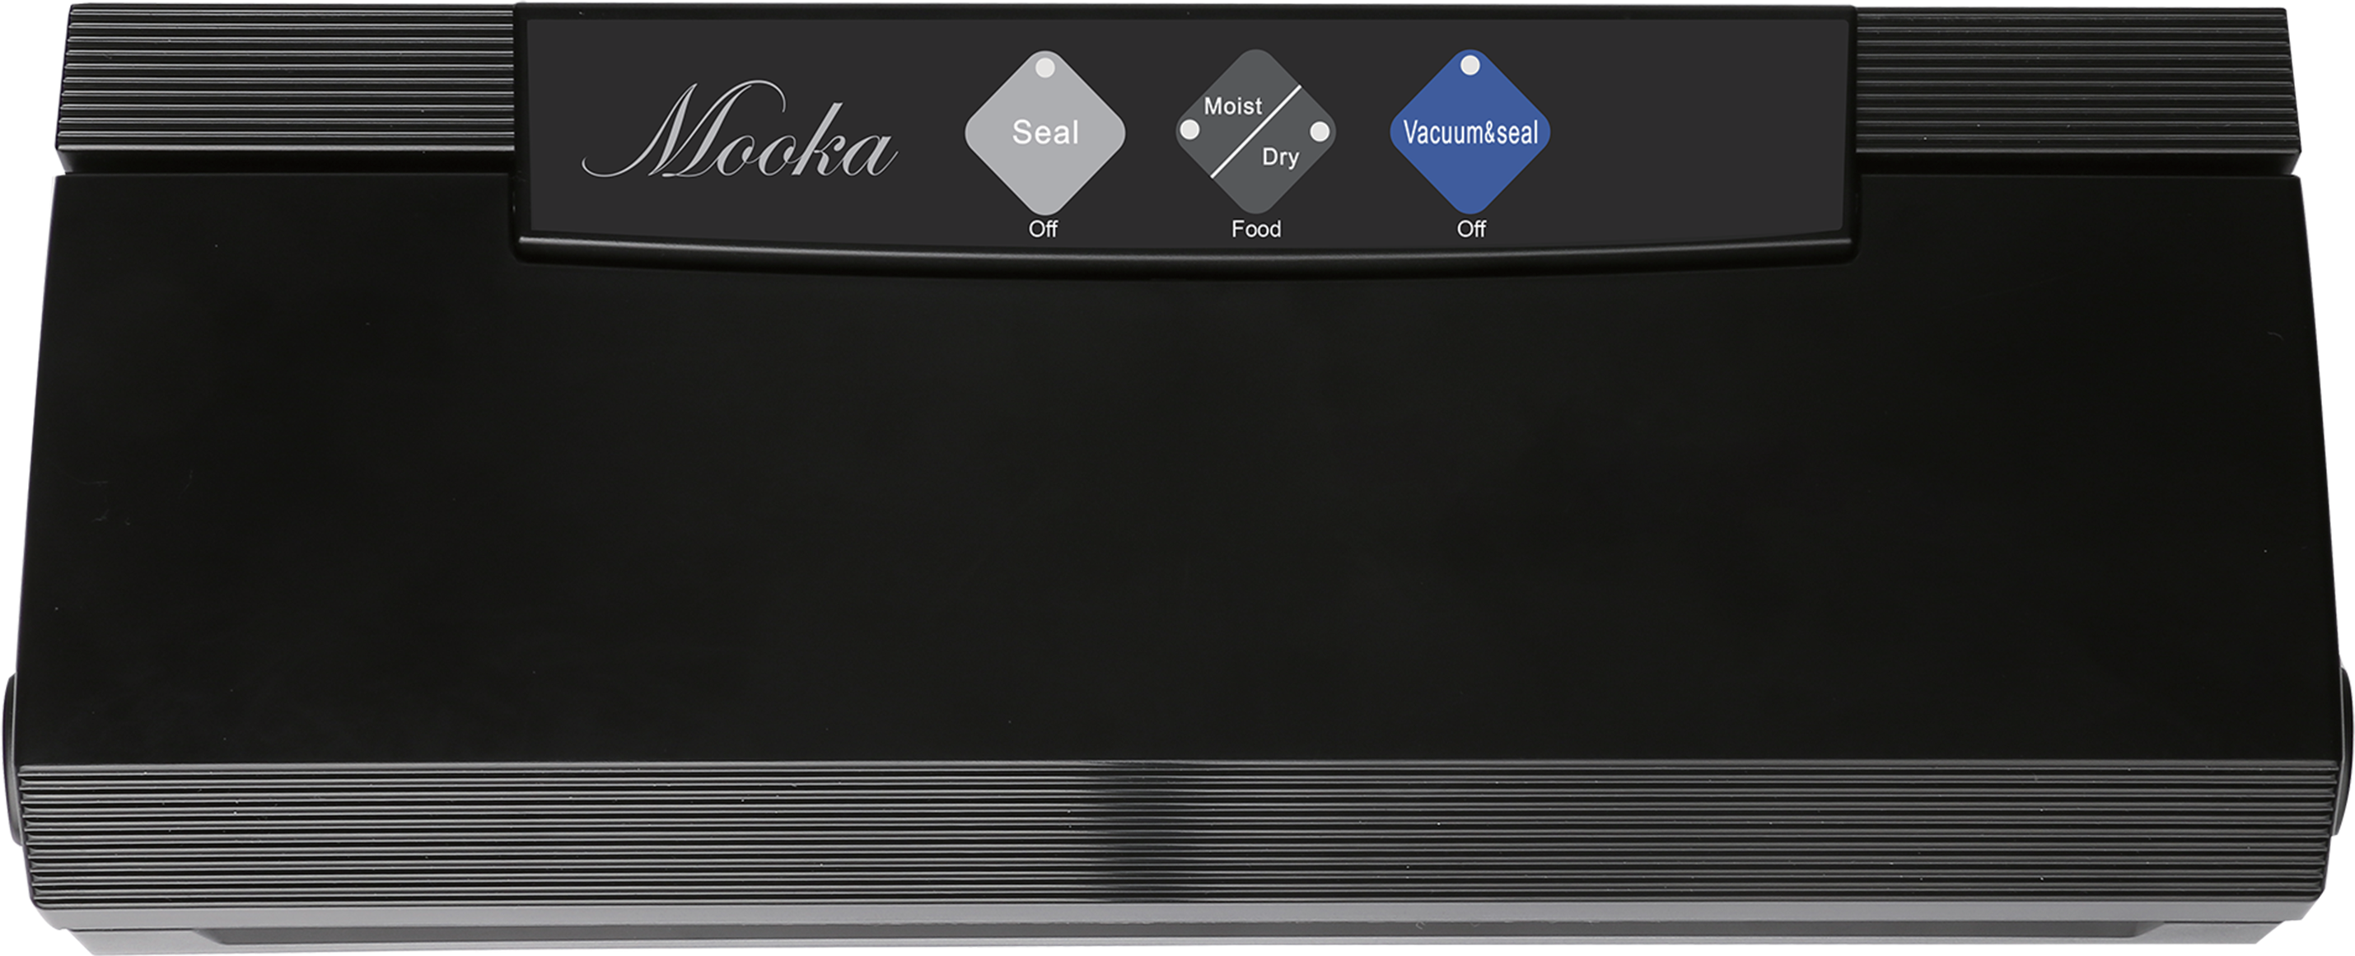

English

mookapro

gasket.

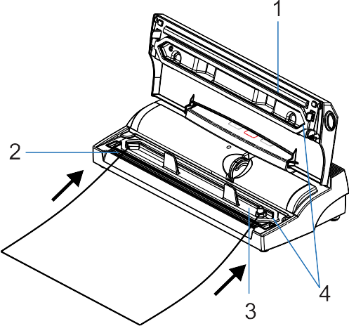

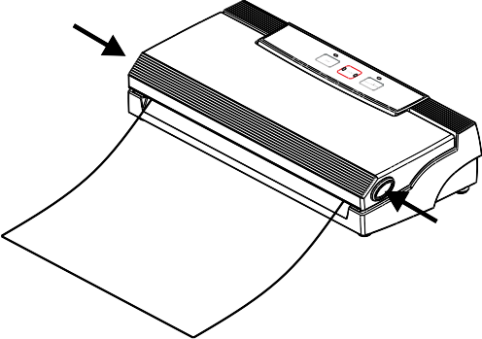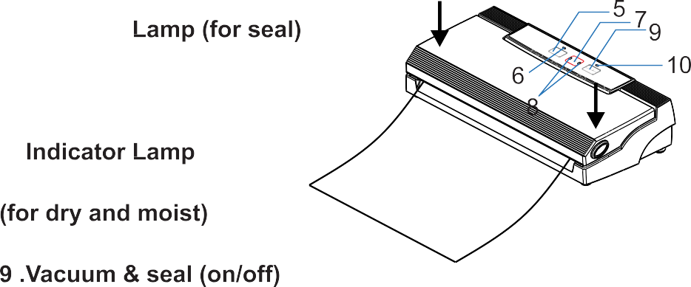

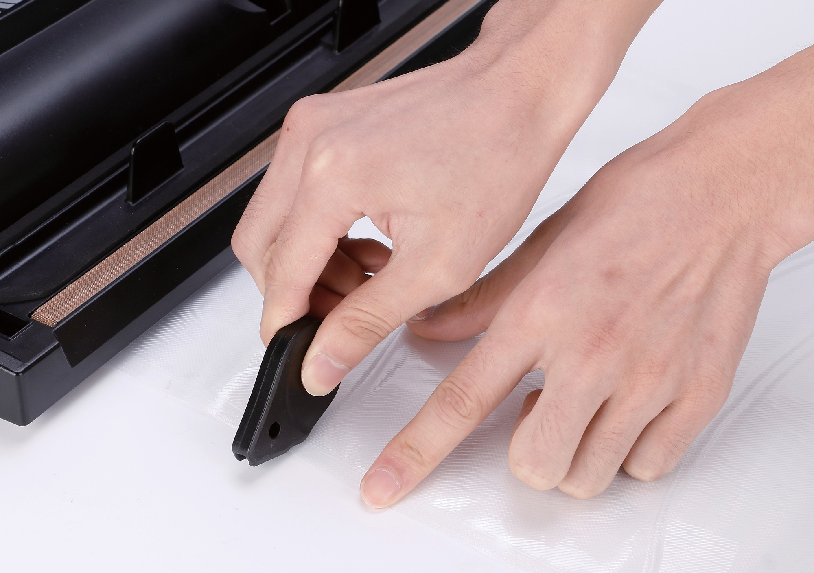

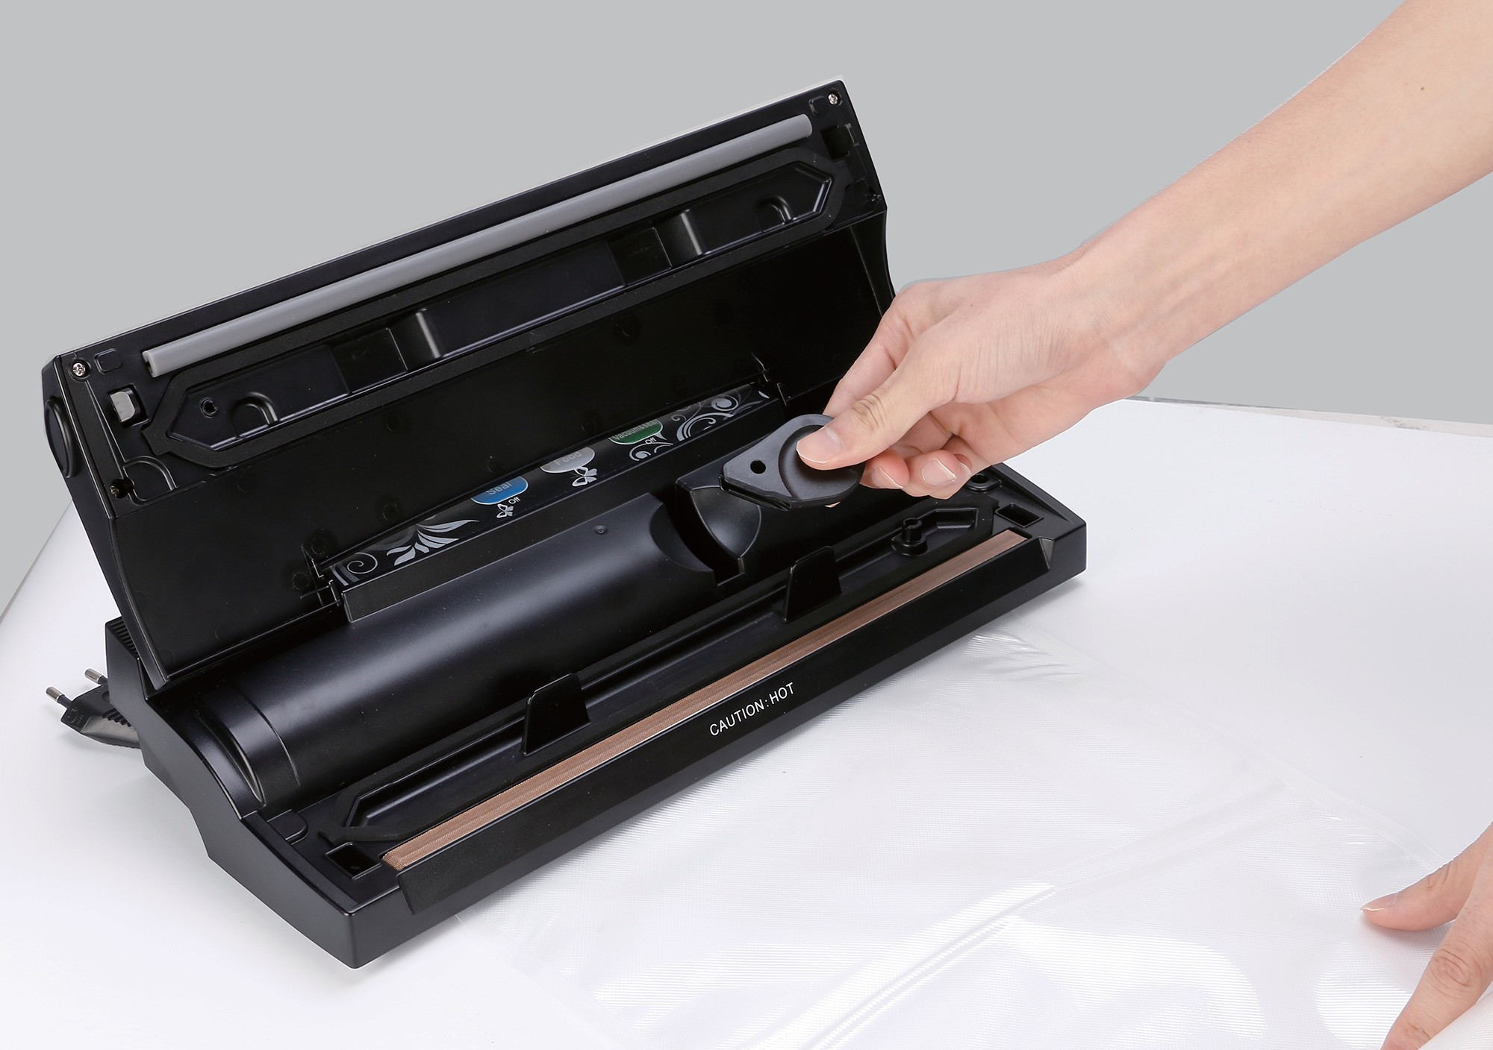
.

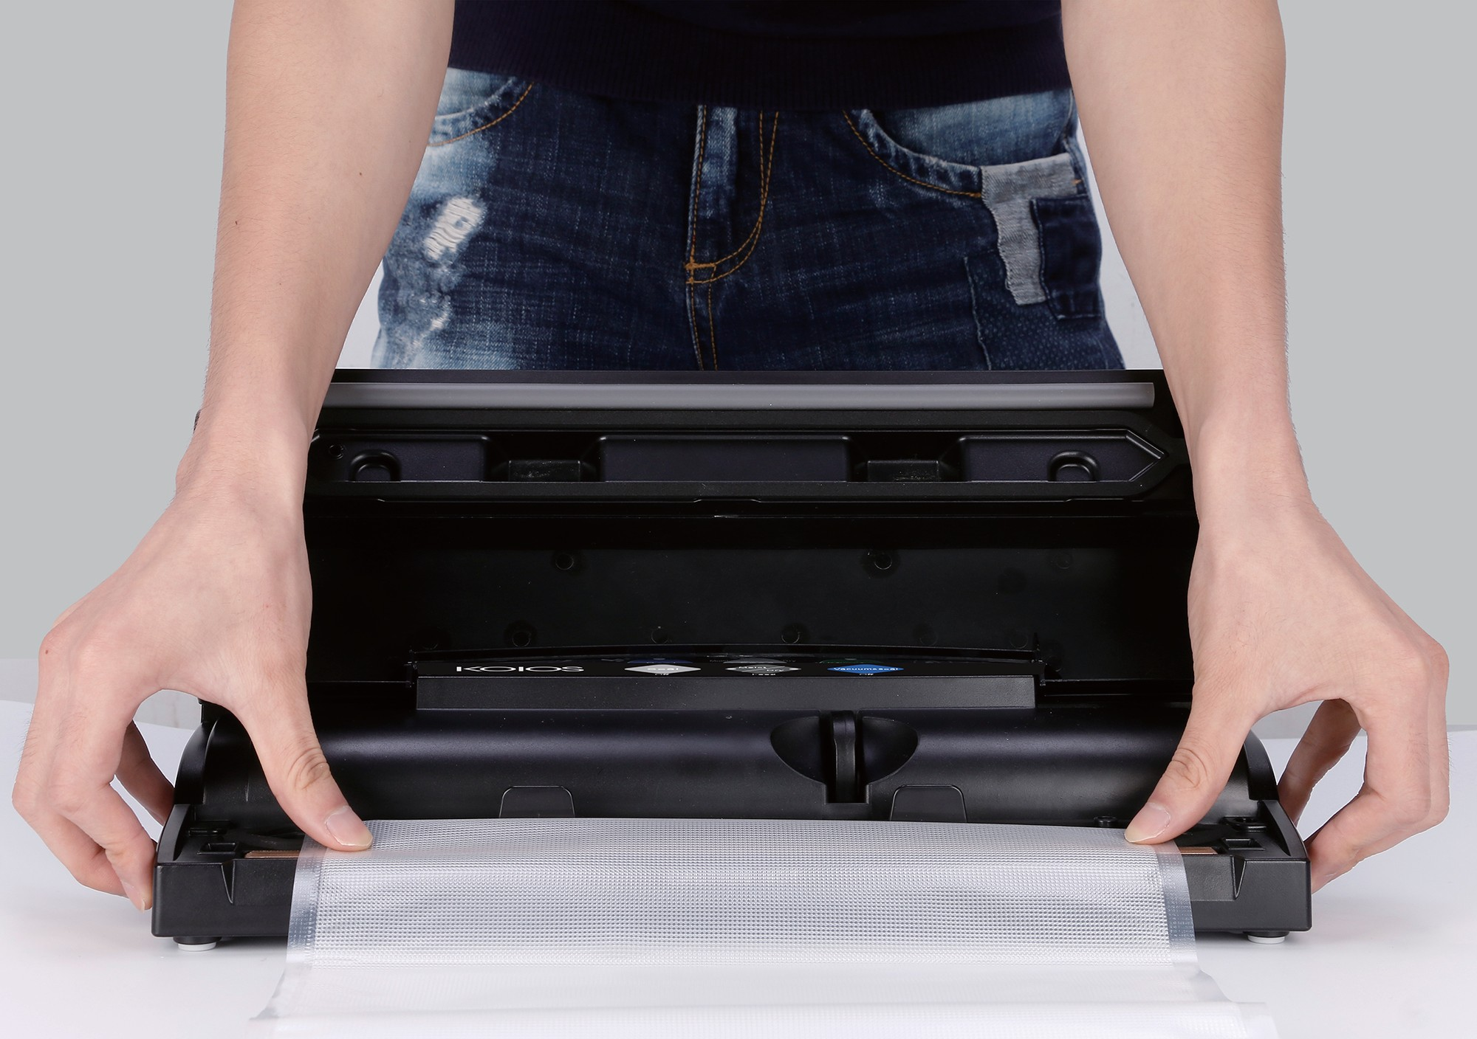
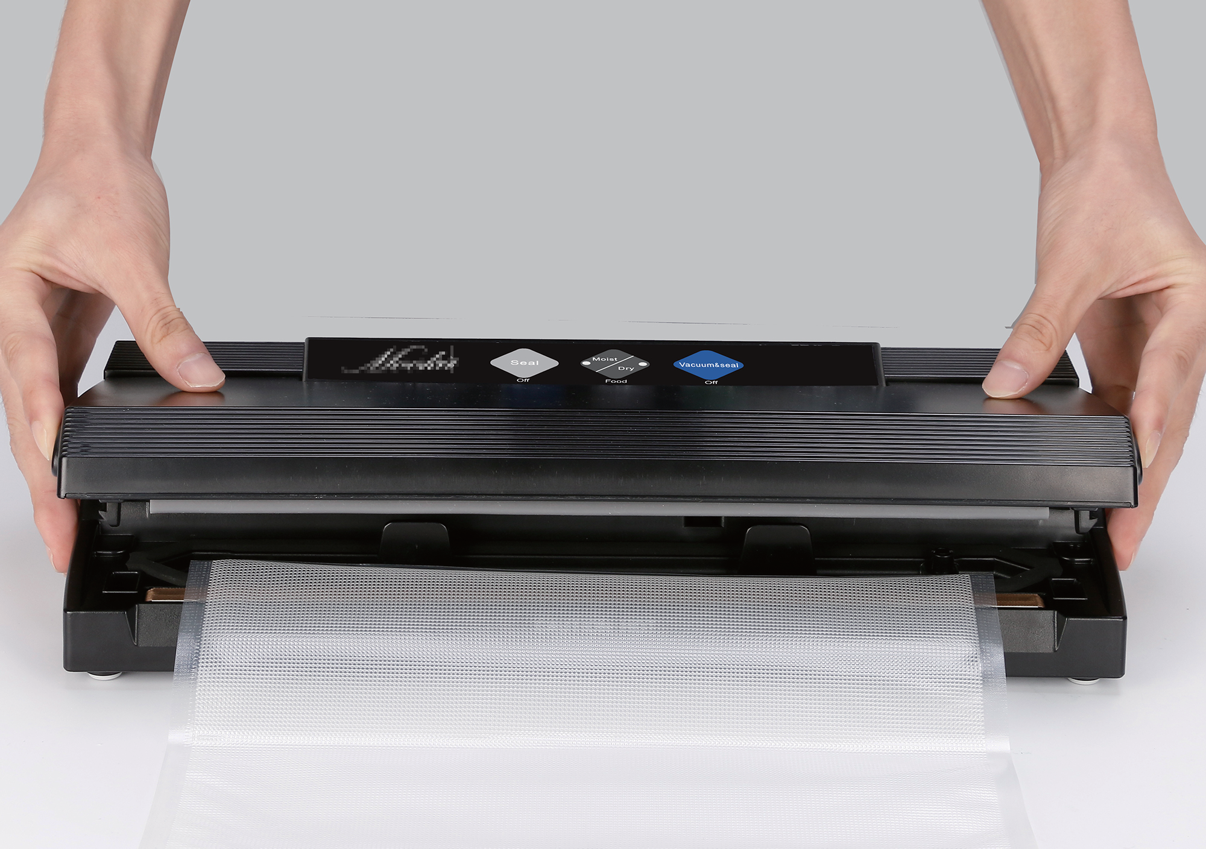
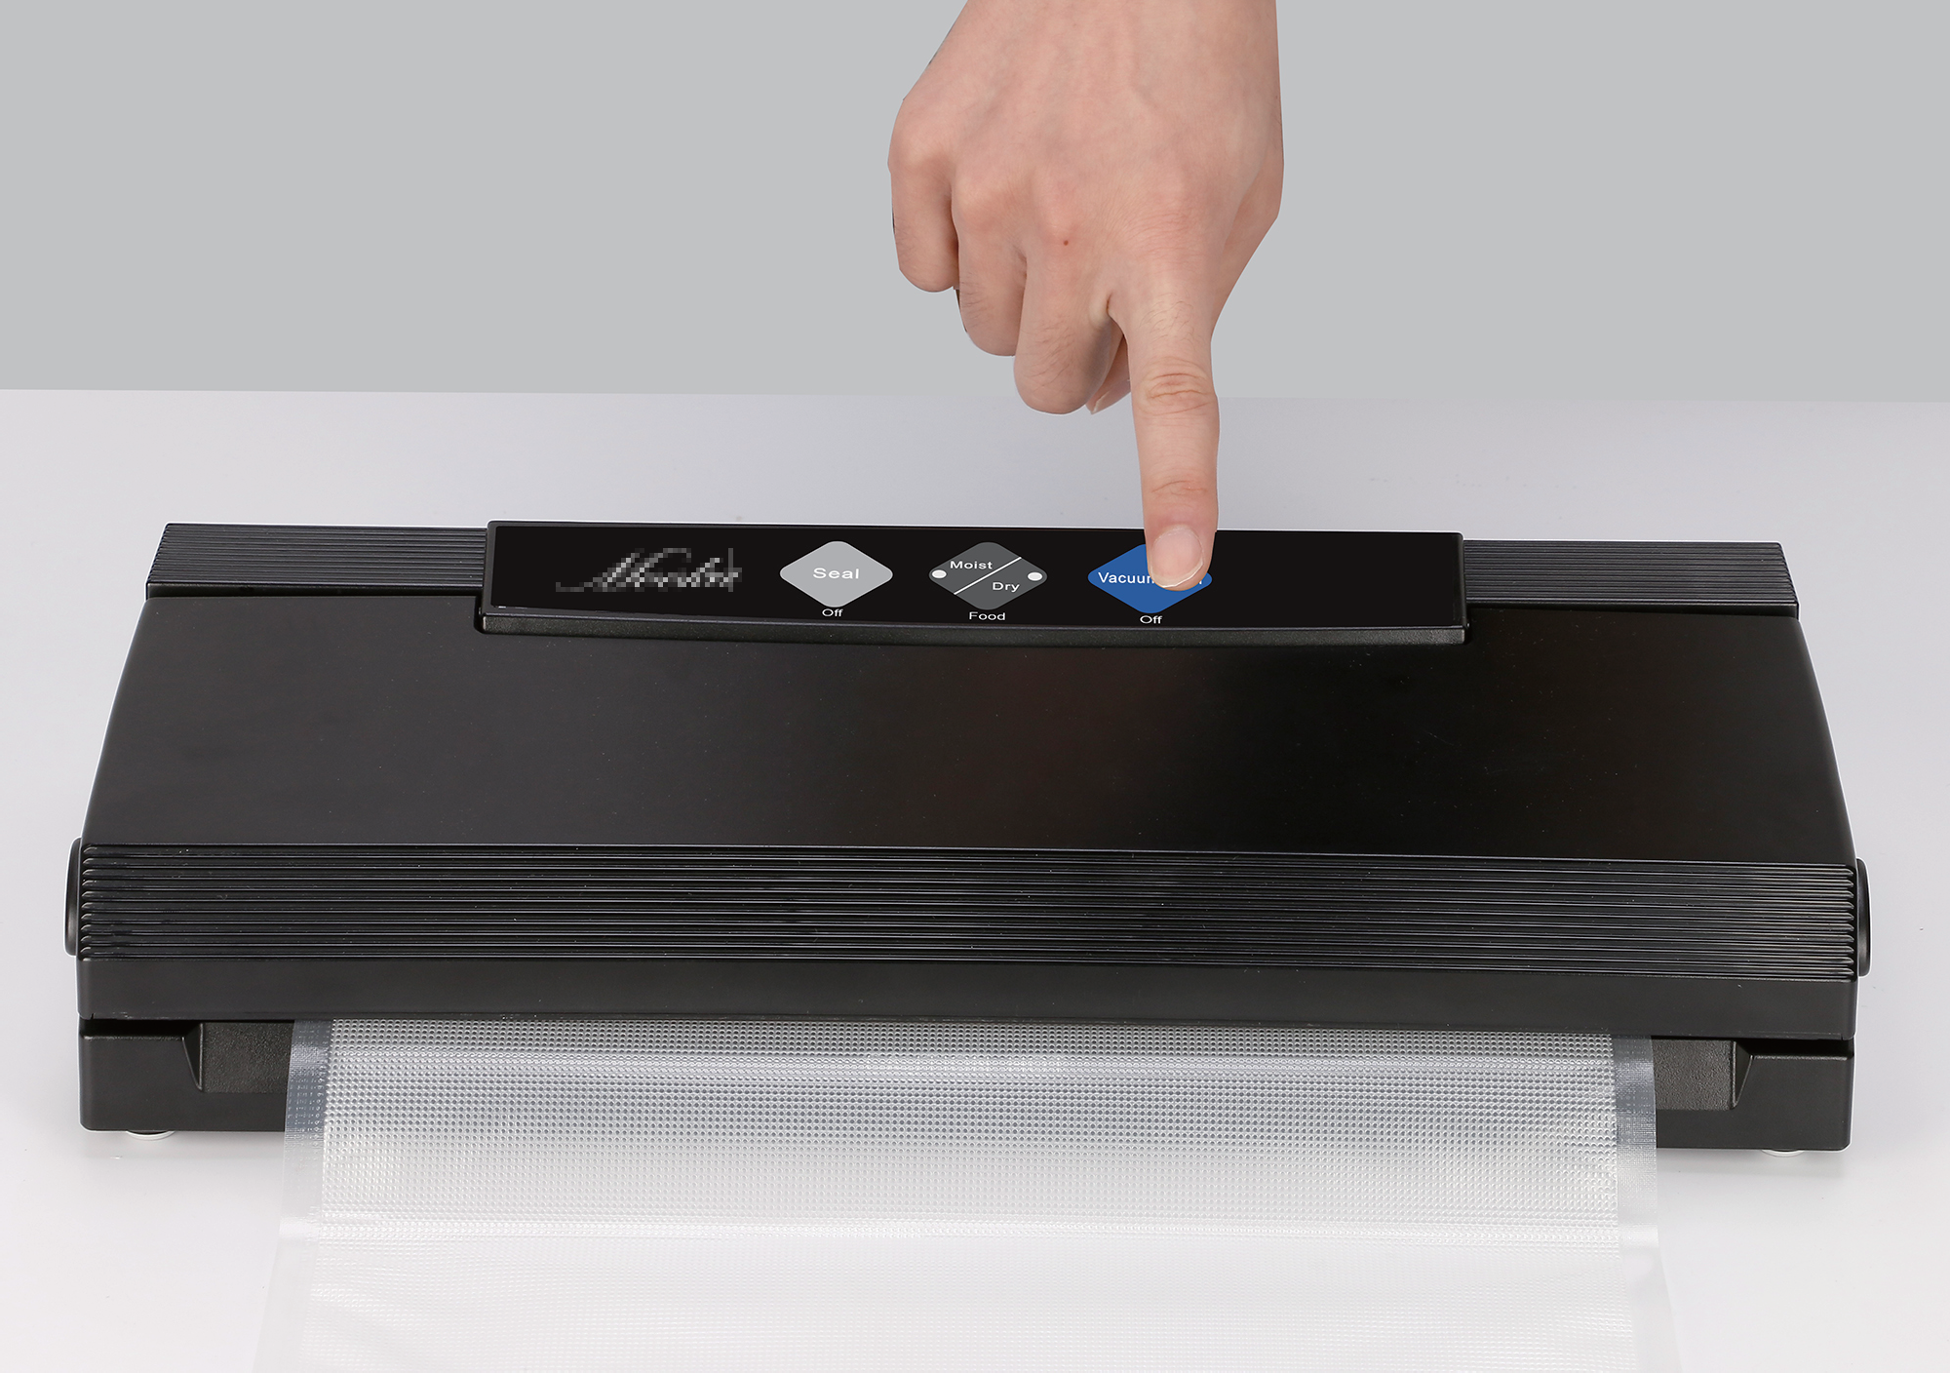
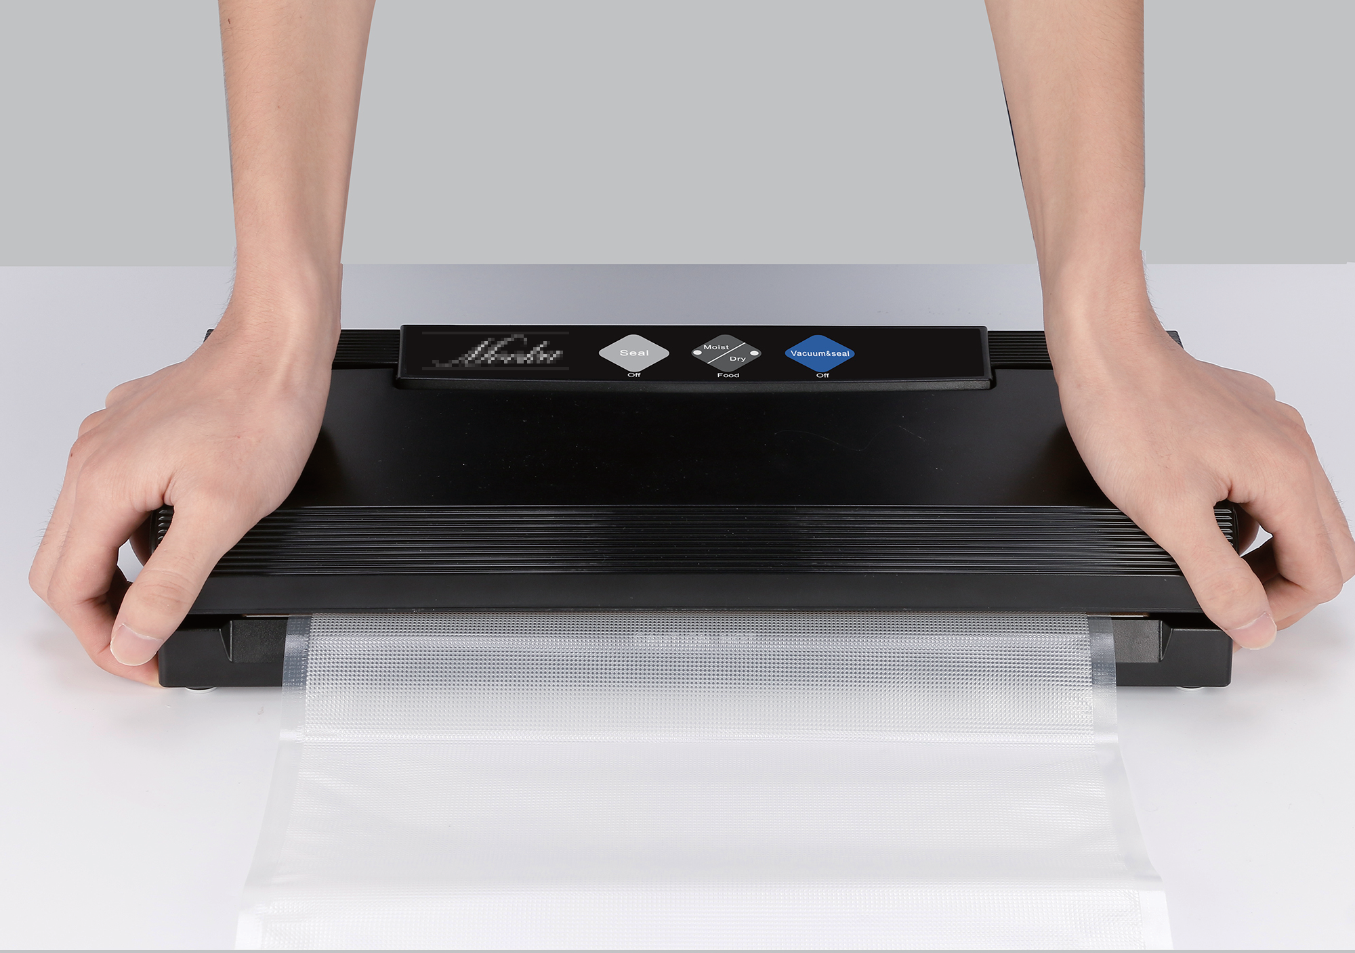

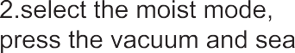

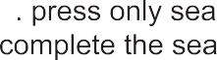

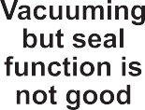 | 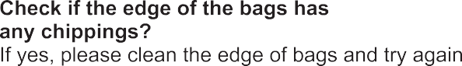
 | 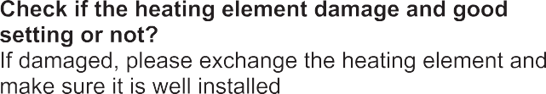
 | 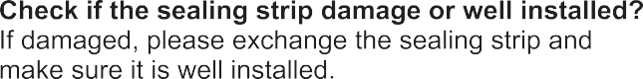
 | 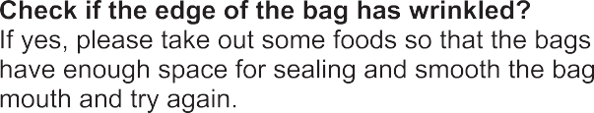
 | 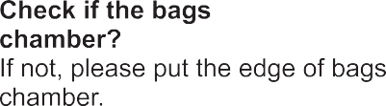
 | 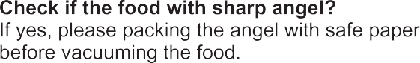

ETL WARNING
- Before plugging cord into wall outlet, or disconnecting, make sure the control is OFF, and unplug from outlet when not in use or before cleaning
- This appliance is not a toy, when used by or near children close attention is necessary, and store this appliance to a safe place, out of the reach of children.
- Do not use any attachments not recommended or appointed, and don’t use this appliance for other purpose except its intended use.
- Stop using the machine immediately if the cord is damaged and have it replaced by a professional.
- Keep away from moving parts.
- Do not try to repair this appliance by yourself.
- Do not use the appliance if it has fallen or if it appears to be damaged.
- Avoid to do the following: pull or carry by the cord, use cord as a handle, close a door on cord, or pull cord around sharp edges or corners. Do not operate appliance over cord or cord / plug is wet.
- Keep away from hot gas, heated oven, electric burner or any other hot surfaces.
- It’s better not to use an extension cord with this unit. However, if one is used, it must have a rating equal to or exceeding the fating of this appliance.
- When disconnect, to avoid any injury, please unplug by grasp the plug, not the cord.
- Before plugging appliance in or operating, make sure your hands are dry and safe to do the actions.
- When it In “ON” or working position, always be on a stable surface, such as table or counter.
- It’s no need to use any lubricant, such as lubricating oils or water, on this appliance.
- When cleaning, do not immerse this appliance in water or any other liquid.
- Do not use this appliance outdoors or on a wet surface, it’s recommended for household, indoor use only.
- This appliance is not intended for use by persons (including children) with reduced physical, sensory or mental capabilities, or lack of experience and knowledge, unless they have been given supervision or instruction concerning use of the appliance by a person responsible for their safety
- Close supervision is required when this product is used near children.
- If the supply cord is damaged, It must be replaced by the manufacturer, its service agent or similarly qualified persons in order to avoid a hazard.
- cleaning and user maintenance shall not be made by children without supervision
- To reduce the risk of electric shock, this product has a polarized plug (one blade is wider than the other). This plug is intended to fit in a polarized outlet only one way. When the plug does not fit fully in the outlet, reverse the plug. When it still does not fit, contact a qualified electrician to install the proper outlet. Do not change the plug in any way.

mookapro
mookapro

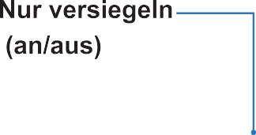

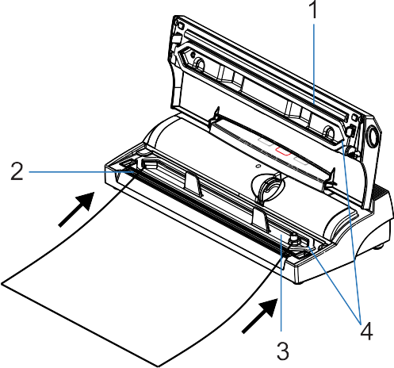
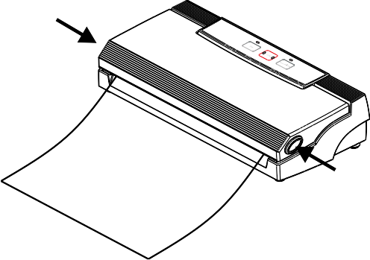

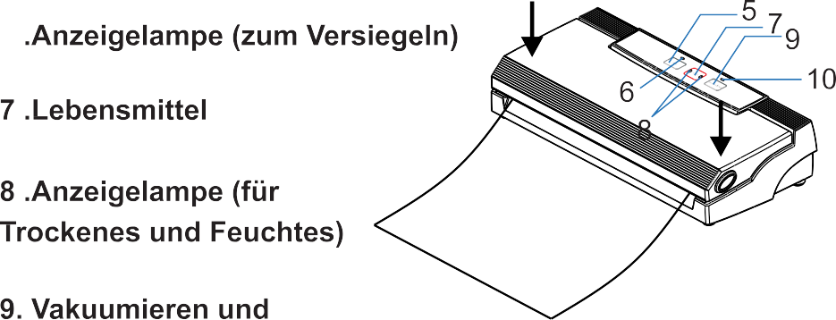

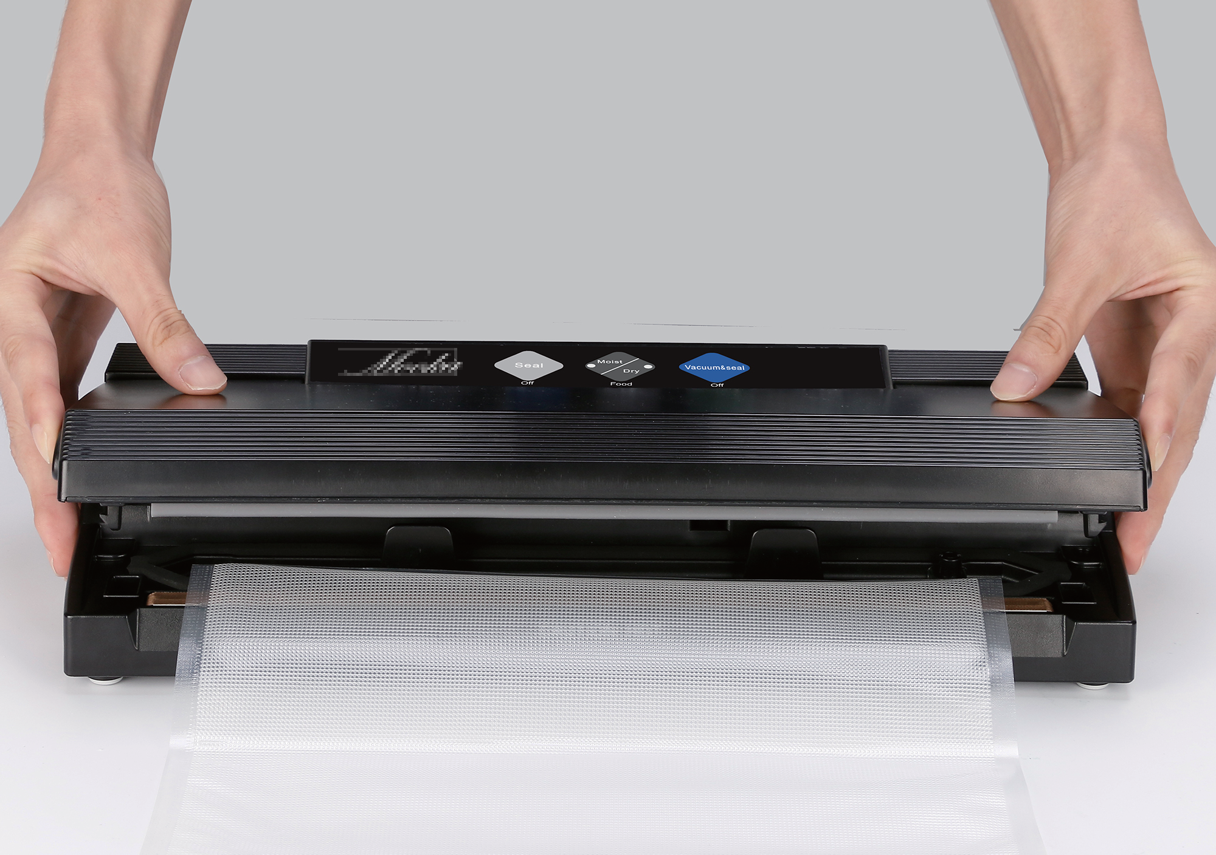
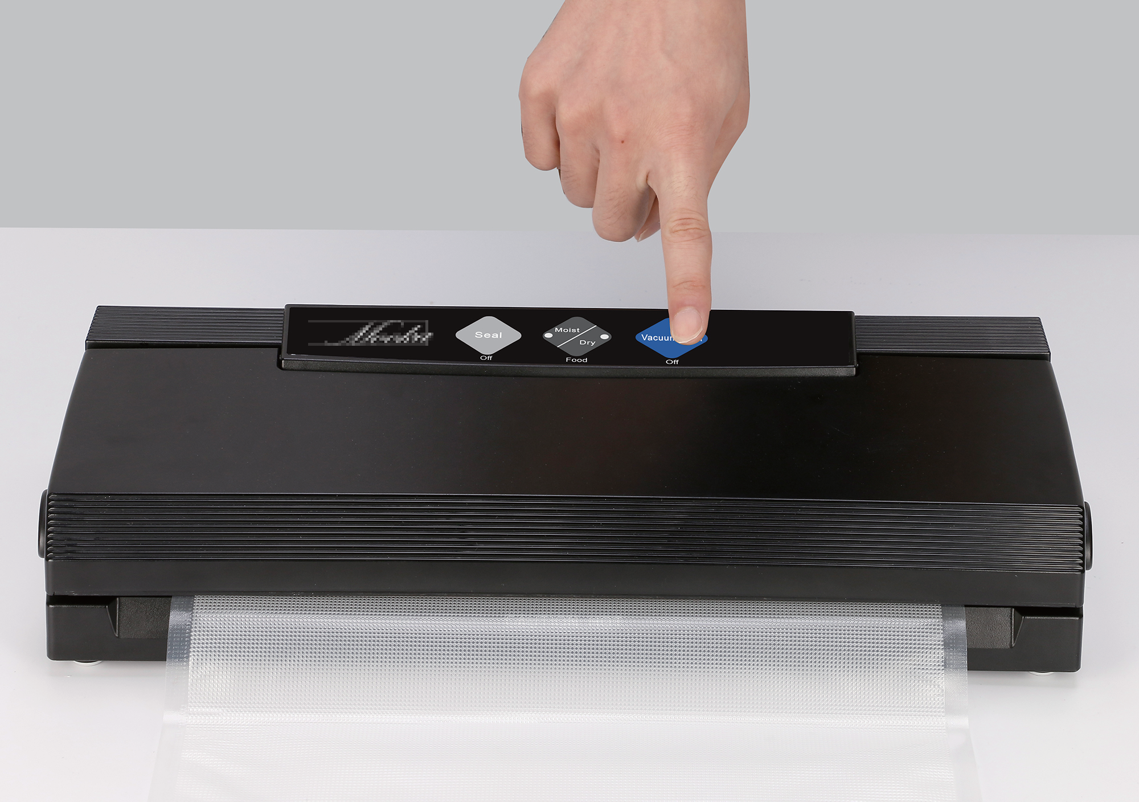
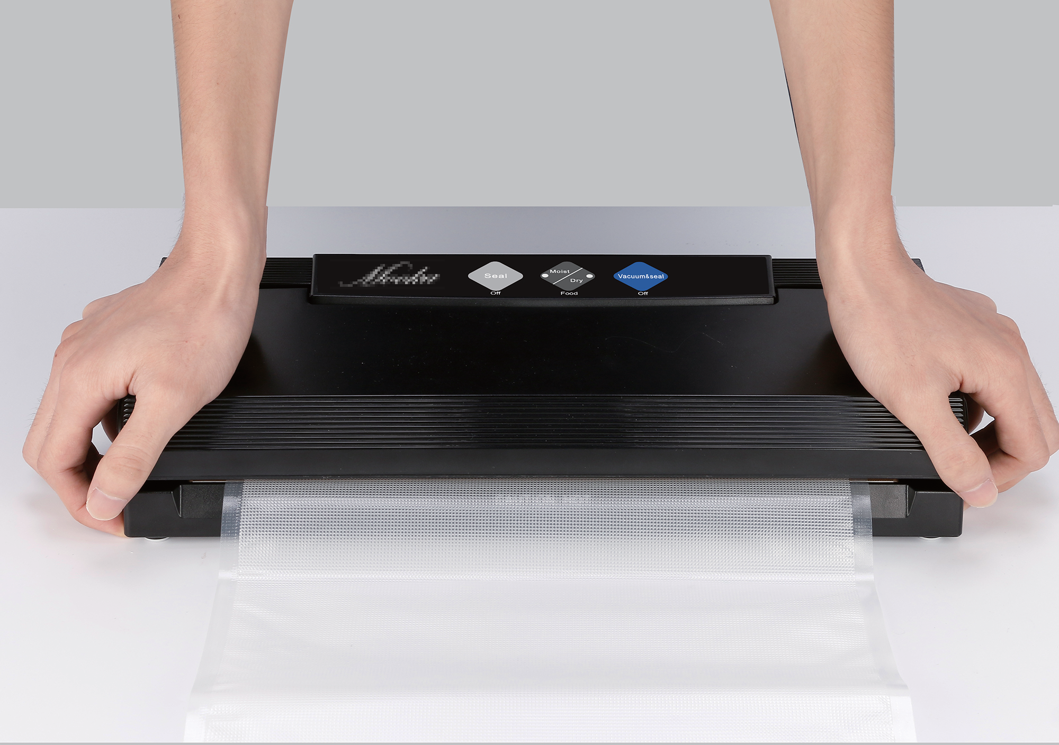

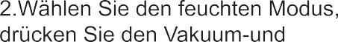

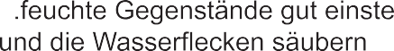

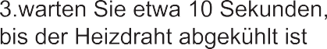

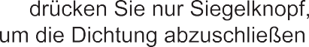

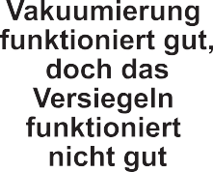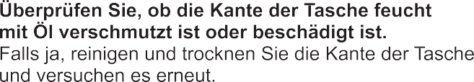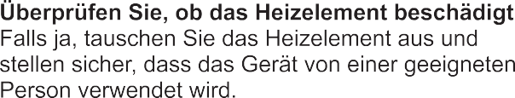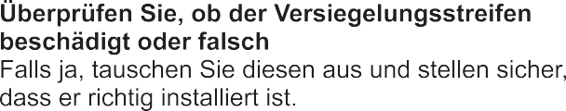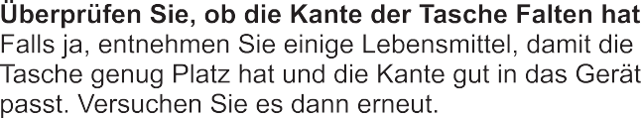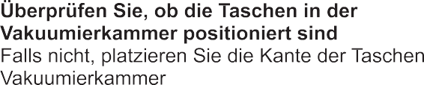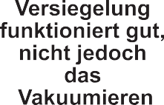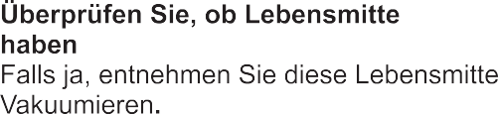

Überprüfen Sie, ob die Kante der Tasche das Saugloch bedeckt

Falls ja, platzieren Sie die Tasche in die korrekte Position.

